**Credential Expiration flow**

1. 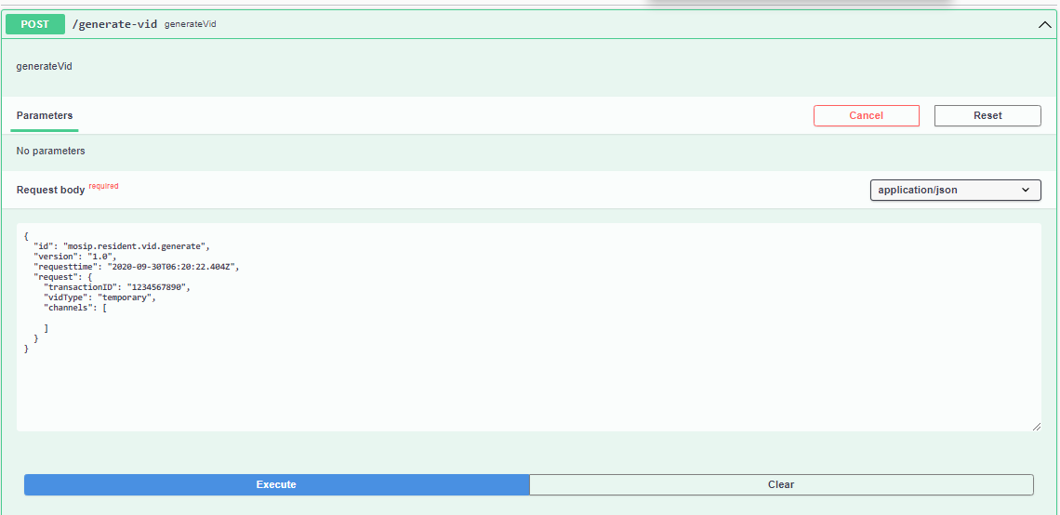Generate a credential.

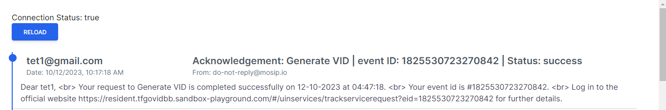Notification

1. 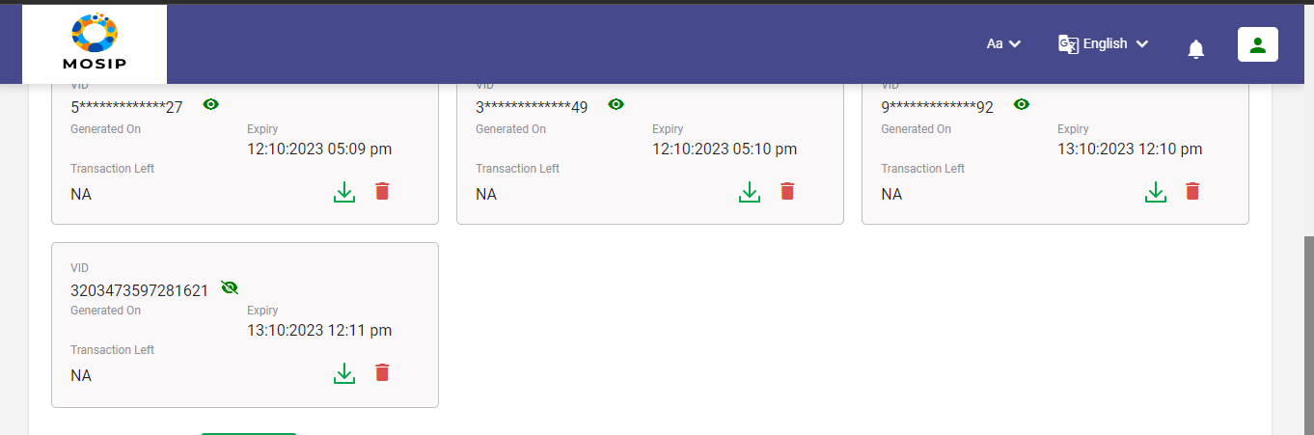Credential getting expired on expiry date.
2. 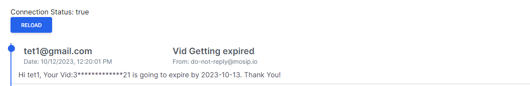Prior notification for credential expiration.
3. 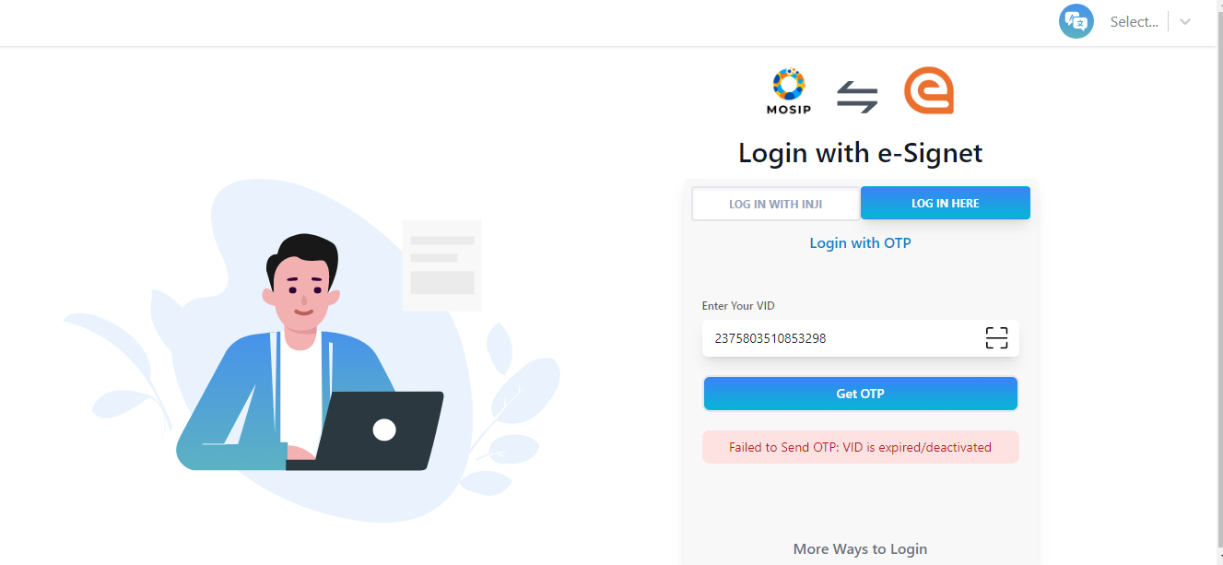Login to Resident portal with expired credential.